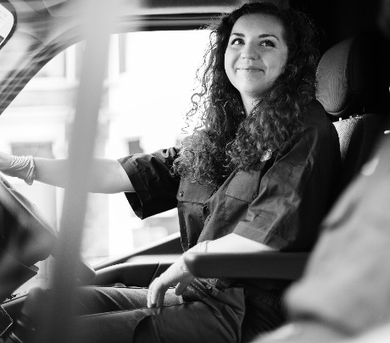

Who Will Benefit?
This workshop is designed for new and existing van drivers

Course Type
1-day workshop
Regional or in-company

Learning Format
Classroom based

What Do You Get?
Course completion certificate

Book online at
www.pinnaclesolutions.net
01952 462300

What’s it all about?
The Van Driver can be described as the ‘Face of the Company’, often they interact with the customer than anyone else in the business, however they are also often overlooked from a development point of view.
This workshop has been designed specifically for the industries fantastic people who drive the van, looking to develop their confidence and communication skills with customers with a goal of providing a first-class customer service experience to your clients on every drop.
Delegates will assess the importance of their role and the ‘Service’ levels they provide identifying their key strengths and areas where improvements can be made to help them gain a more focused approach
They will cover some of the basics of good vehicle maintenance, safe driving and effective route planning as well as learning some really simple ways that they can help to grow the business by gaining additional orders and gathering leads.
Finally, they will be encouraged to set quality, measurable, individual goals to take back to the business and implement.
What will be covered in this module?
- What is your experience of delivery services?
- Your service levels and expectations.
- Your customer’s real expectations
- 1st Impressions on every drop
- Vehicle care and safe driving
- Effective route planning
- The journey from order to delivery
- Selling from the van
- Gathering sales leads and feedback
What will the delegates be able to do on completion?
- Understand how they personally effect the impression of the business
- Have the confidence when communicating with the customer
- Work to a new standard of service, striving for excellence – Right 1st time, every time
- Develop and evolve a culture of “customer focus”
- Increase motivation and become more involved in customer service
- Increase sales for the branch by having a proactive approach

